**Final Report – LC Project**

**Snake Game Invasion**

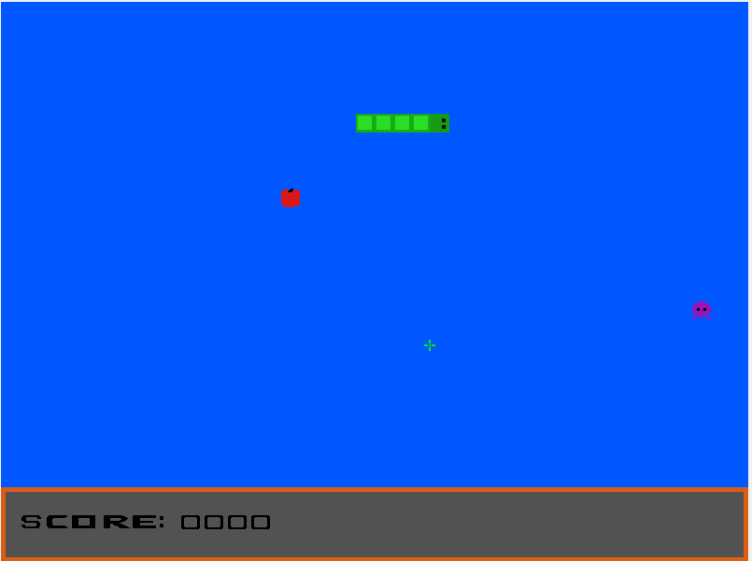

**Group T02 G08**

André Morais – up202005303

Aníbal Ferreira – up202005429

Bárbara Rodrigues – up202007163

José Albano – up202008561

**Index**

1. User instructions
2. Project status
3. Code organization/structure
4. Implementation details
5. Conclusions
6. **User Instructions**

The project is a single player game inspired by the classic snake game released to Nokia phones in the 90’s. The game differs from the original, we play as a snake that needs to catch apples to grow but is also chased by alien enemies that try to kill it.

The game begins in the main menu where you can use the mouse to over the ‘play’ or ‘exit’ options and click to choose one of the options or you can use the arrow keys and press enter to select those options as well.

At any time you can press ESC to leave the game.

Inside the game, you can at any time press the ‘P’ key to pause the game and the game will be stopped where it was left. To return to the game you need to press ‘P’ again and the game will continue. In game, if you press the ESC key you leave to the main menu.

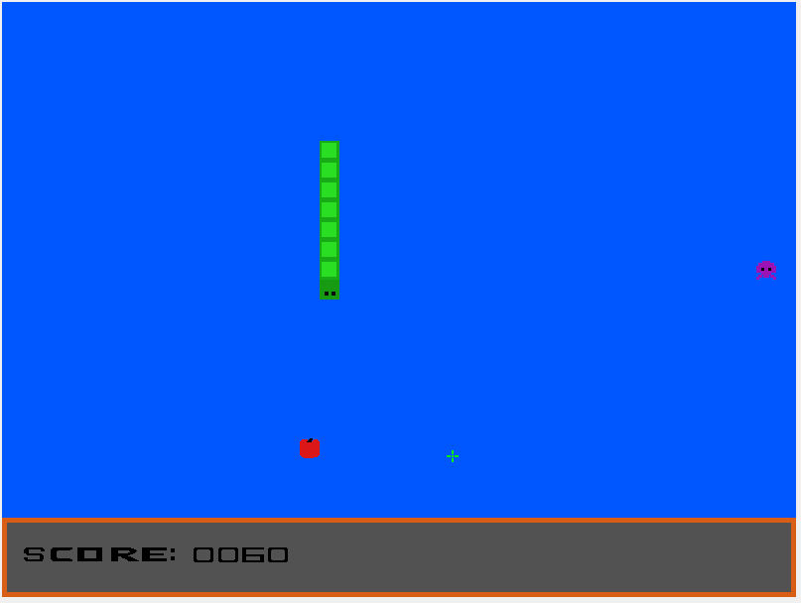

You can move the snake using W, A, S, D keys or the up, left, right and down key arrows to move the snake across the screen in those directions.

You can pick up apples to grow and earn score. You need to avoid the enemies by killing them clicking on them with the left mouse button.

If the enemy hits you, your score will decrease 50 points and your size will also be decreased by one unit. Also, if your score is less than 50 and the enemies hit you, then the game ends and your score will be 0.

If the snakes head hits itself the game ends.

Once you die the game over screen will appear showing you the score at the end of the game and the date and time of the death of the snake.

In the game over screen, you can press ‘Q’ to go back to the main menu.

1. **Project status**

**Implemented features:**

Devices Table

|  |  |  |
| --- | --- | --- |
| **Device** | **Usage** | **Interrupt/polling** |
| Timer | Updates the display and controls the game’s frame rate | Interrupts |
| Keyboard | Game navigation, pause button and player movement | Interrupts |
| Mouse | Menu navigation and player attacks in-game | Interrupts |
| Video Card | Menus and screen display | N/A |
| RTC | Date and time of the end of the game | Polling |

# Timer

Used to update the game screen and the game logic including player and enemy movement at a consistent frame rate.

**Functions:**

* proj_main_loop() - Changes in what game loop the game is in
* menu_loop() - Loop that controls the menu display
* game_loop() - Updates game display and game logic
* gameOver_loop() – Controls the game over screen display

# Keyboard

# Mouse

# Video Card

# RTC

//inimigos

//matar os gajos

//score

//game over

(depois dizer a parte do ecra e da cross hair e modos cor) o movimento da cobra ser controlado e vai se mexendo sozinha tal como os inimigos